

ELEC4848 Senior Design Project 2025-2026
Department of Electrical and Electronic Engineering

Chan Yu Sing (3035930345)
Computing with diffraction
Supervisor: Prof. Kenneth Wong
Second Examiner: Prof. Edmund Lam

ABSTRACT

This report presents the design, simulation, training, and independent numerical validation of an LCD-based diffractive optical neural network (ONN) for handwritten digit classification on MNIST. The system comprises two amplitude-modulating layers, each realized as a 200 × 200 pixel monochrome liquid-crystal display with 138.3 µm pixel pitch, illuminated by a 532 nm laser with 50 mm inter-layer spacing. Field propagation is modelled using the Angular Spectrum Method in a differentiable PyTorch framework. Five detection architectures were trained under identical conditions; the max-zone 5 × 5 detector achieved 90.85% test accuracy — within 0.9 percentage points of the 91.75% benchmark of Lin et al. [1] using five phase-modulating layers and at over two orders of magnitude lower hardware cost. Results were independently reproduced in NumPy and MATLAB, confirming that the trained float32 angular spectrum transfer function must be preserved exactly to avoid a precision-induced accuracy collapse to approximately 43%. Hardware assembly and physical characterization are identified as the primary remaining objectives.

AKNOWLEDGEMENT

The author wishes to express sincere gratitude to Prof. Kenneth K.Y. Wong for his expert supervision and guidance throughout this project. The author also acknowledges the support provided by the Department of Electrical and Electronic Engineering at The University of Hong Kong.
TABLE OF CONTENTS

1. Introduction 11
1.1 Background 11
1.2 Project Objectives 12
1.3 Report Organization 12
1.4 Project Planning 13
2. Related Works 14
2.1 Diffractive Deep Neural Networks 14
2.2 Amplitude- vs. Phase-Modulating Systems 15
2.3 Reviews and Broader Context 16
3. Methodology 18
3.1 System Architecture 18
3.2 Light Propagation Model 19
3.2.1 Angular Spectrum Method 19
3.2.2 Justification for ASM 20
3.3 Amplitude Modulation and LCD Selection 20
3.3.1 Modulation Scheme 20
3.3.2 Justification for LCD Over Alternative Technologies 21
3.3.3 LCD Non-Idealities 21
3.4 Multi-Layer Diffractive Design 22
3.5 Detection Methods 23
3.6 Training Procedure 25
3.6.1 Input Preprocessing 25
3.6.2 Optimizer 26
3.6.3 Learning Rate Schedule 26
3.6.4 Loss Function and Regularization 27
3.6.5 Summary of Hyperparameters 27
3.7 Software Architecture 28
4. Results and Discussion 30
4.1 Detection Method Comparison 30
4.2 Max-Zone Training Analysis 32
4.2.1 Zone Collapse in the 4 × 4 Configuration 32
4.2.2 Resolution Through Grid Expansion and Adaptive Scheduling 33
4.3 Per-Class Accuracy of the Final Model 35
4.4 Learned Amplitude Masks 37
5. Independent Validation 39
5.1 NumPy Validation 39
5.1.1 Validation Procedure 39
5.1.2 Results 40
5.2 MATLAB Validation 40
5.2.1 Validation Procedure 40
5.2.2 MATLAB Results 41
5.3 Float32 Precision Dependency 41
5.3.1 Physical Origin 41
5.3.2 Effect on Accuracy 42
5.3.3 Implication and Fix 42
6. Conclusion 44
6.1 Summary 44
6.2 Significance and Contributions 44
6.3 Limitations 45
6.4 Future Work 46
7. References 47

LIST OF FIGURES
Fig.1. System architecture of the two-layer LCD based ONN 18
Fig.2. Max-zone 5x5 detector zone-to-class assignment map 25
Fig. 3. Training and validation accuracy curve for the max-zone 5x5 model 34
Fig. 4. Per class test accuracy of the max-zone 5x5 model on 10,000-image MNIST test set 35
Fig. 5. Row-normalized confusion matrix for the max-zone 5x5 model on the 10,000-image MNIST test set 36
Fig. 6. Trained amplitude masks for Layer1 (left) and Layer 2 (right) of the max-zone 5x5 model 37

LIST OF TABLES
Table 1 Project milestone schedule 13
Table 2 Hardware specifications of the LCD optical system 19
Table 3 Comparison of light propagation simulation methods 20
Table 4 Comparison of spatial light modulator technologies 21
Table 5 Final training hyperparameters 27
Table 6 Software module structure 28
Table 7 Detection method accuracy comparison on the MNIST test set 30
Table 8 Per-class test accuracy (%) for all detection methods 31

ABBREVIATIONS
Abbreviation | Full Form
ASM | Angular Spectrum Method
D²NN | Diffractive Deep Neural Network
DMD | Digital Micromirror Device
FFT | Fast Fourier Transform
LCOS | Liquid Crystal on Silicon
LCD | Liquid-Crystal Display
MNIST | Modified National Institute of Standards and Technology (handwritten digit dataset)
ONN | Optical Neural Network
SLM | Spatial Light Modulator

LIST OF SYMBOLS
Symbol | Definition | Unit
λ | Optical wavelength | m
k | Free-space wavenumber, k = 2π/λ | rad m⁻¹
k_x, k_y | Transverse wavenumber components | rad m⁻¹
k_z | Longitudinal wavenumber component, k_z = √(k² − k_x² − k_y²) | rad m⁻¹
z | Propagation distance between layers | m
H | Angular spectrum transfer function | —
U | Complex optical field amplitude | —
T | Pixel amplitude transmission (T ∈ [0, 1]) | —
M_ℓ | Amplitude mask tensor for layer ℓ | —
W | Zone-to-class assignment logit matrix | —
s | Learnable logit scale factor | —
τ | Gumbel-SoftMax temperature parameter | —
η | Current learning rate | —
η₀ | Initial learning rate | —
ε | Label smoothing coefficient | —
δ | Numerical stabilizer (prevents division by zero) | —
Eᵢ | Total energy (sum of pixel intensities) of image i | —
Ē | Mean total energy over the training set | —
Δx | Pixel pitch | m
N | Grid dimension (number of pixels per side) | —

Introduction
  - Background
Machine learning inference has experienced explosive growth in computational demand. Modern neural networks require billions of multiply-accumulate operations per input, and large-scale deployment in data centers imposes substantial energy costs [2]. Graphics processing units consume several hundred watts per card for inference workloads at scale, and the International Energy Agency projected that global data center electricity consumption would reach 1,000 TWh per year by 2026 [13]. This trajectory has renewed interest in alternative computing substrates that can perform inference with lower power consumption and higher throughput than transistor-based implementations.
Optical computing presents one such alternative. Coherent light propagates at c = 3 × 10⁸ m/s, and diffractive optical elements can implement complex linear transformations in parallel across the full spatial extent of an optical wavefront. A single 200 × 200 pixel spatial light modulator performs 40,000 parallel multiplications per exposure — the equivalent of a 40,000-dimensional vector multiplication — at the speed of light and with no dynamic power consumption beyond the illumination source. Computation occurs passively as light travels between layers, requiring no active switching elements. Lin et al. [1] demonstrated the feasibility of this paradigm by training Diffractive Deep Neural Networks (D²NNs) comprising 3D-printed phase masks achieving 91.75% accuracy on handwritten digit classification. Their work established the theoretical basis for treating physical diffraction as a computational primitive and showed that backpropagation through a differentiable wave-optics simulation is an effective method for designing diffractive optical processors.
However, 3D-printed phase masks cannot be reprogrammed after fabrication, which limits their utility during system development and prevents updating the network after deployment as data distributions shift. Spatial light modulators (SLMs) capable of phase modulation are electronically reprogrammable but cost more than USD 10,000 per unit, placing them out of reach of most research groups. Commercial liquid-crystal displays (LCDs) offer a programmable, low-cost alternative: a monochrome 200 × 200 pixel LCD costs under USD 50 and, being a transmissive electro-optic device, can be updated between exposures without mechanical realignment. This project investigated whether such commodity hardware can implement a functional ONN for digit classification, establishing a low-cost entry point to experimental optical computing research.

  - Project Objectives
This project aimed to design, simulate, train, and numerically validate an LCD-based ONN for MNIST handwritten digit classification. The specific objectives were as follows:
1. Develop a differentiable simulation framework implementing the Angular Spectrum Method (ASM) for accurate optical field propagation between LCD layers. The framework was required to support automatic differentiation through the full wave propagation pipeline so that mask patterns could be optimized by standard gradient-based methods.
2. Model realistic LCD characteristics, including pixel fill factor, contrast ratio limits, and binary quantization constraints, to ensure the simulation results are physically meaningful and transferable to real hardware.
3. Train amplitude masks for two diffractive layers via gradient-based optimization and compare multiple output detection schemes to identify the architecture best suited to physical hardware read-out, with minimal post-optical computation at the detector.
4. Validate the trained simulation independently using a second numerical implementation to confirm that results are reproducible and not artefacts of the PyTorch training framework, and to identify any numerical precision issues that would affect hardware deployment.
Objectives 1–4 were fully achieved in simulation. Physical hardware assembly, originally envisaged as a fifth objective, was not completed within the project period and is identified as the primary direction for future work in Section 6.

  - Report Organization
The remainder of this report is structured as follows. Section 2 surveys related work in diffractive neural networks and optical computing hardware. Section 3 describes the system architecture and training methodology, including justifications for key engineering choices. Section 4 presents result from the five-method detection comparison and analyses the max-zone training dynamics that achieved 90.85% test accuracy. Section 5 describes the independent numerical validation in NumPy and MATLAB and discusses the float32 precision dependency identified during that process. Section 6 concludes the report with a discussion of significance, limitations, and future directions. The findings from each section build cumulatively toward the overall assessment presented in Section 6.

  - Project Planning
Table 1 summarizes the project timeline against the planned schedule. All simulation and software objectives were completed on schedule. Physical hardware assembly was scoped as an aspirational final phase, contingent on completing the simulation validation; with validation concluding in March 2026, assembly was deferred to future work.
Table 1 Project milestone schedule
Phase | Planned period | Key deliverables | Status
Literature review | Sep–Oct 2025 | Summary of D²NN, ONN, ASM literature | Complete
Framework development | Nov–Dec 2025 | Differentiable ASM in PyTorch. | Complete
Multi-method comparison | Feb 2026 | Five detection architectures trained | Complete
Independent validation | Mar 2026 | NumPy and MATLAB reproductions | Complete
Hardware assembly | Post-submission | Optical breadboard; physical MNIST evaluation | Future work

The overall schedule was met for all completed phases. The hardware phase was not started within the project period and is acknowledged as the primary remaining objective in Section 6.

Related Works
This section surveys prior work relevant to the present project. 2.1 reviews the seminal D²NN framework and subsequent extensions. 2.2 discusses the tradeoffs between amplitude- and phase-modulating systems. 2.3 situates the work within broader reviews of the optical neural network field.

  - Diffractive Deep Neural Networks
The concept of implementing neural network computations through physical diffraction was formalized by Lin et al. [1], whose D²NN architecture used multiple phase-modulating layers separated by free space to classify handwritten digits and fashion items with 91.75% accuracy on the MNIST test set. Five phase-modulating layers, each fabricated as a 3D-printed acrylic plate with a spatially varying surface relief encoding a [0, 2π) phase map, were cascaded with 30 mm free-space gaps at 0.4 THz. Each diffractive layer modulates the phase of the incoming optical field, and free-space propagation between layers performs spatial mixing analogous to a weighted summation in an electronic network. Training is performed numerically using backpropagation through a differentiable scalar-wave simulation (the same Angular Spectrum Method used in the present work), and the final optimized phase profiles are transferred to fabricated elements. The key insight of Lin et al. is that the real and imaginary parts of the complex transmission function at a diffractive layer map onto the weights of a neural network neuron, so the Huygens-Fresnel superposition integral across the layer corresponds to a weighted summation across all input pixels — a linear transformation of the input field. Non-linearity enters only through the intensity detector at the final layer, which computes |U|²; all intermediate layers perform complex-valued linear transformations. This seminal demonstration established that coherent light propagation could implement a cascade of spatial linear transformations sufficient to realize non-trivial discriminative functions without any active electronic switching.
Subsequent work has extended the D²NN framework to more complex tasks and modalities. Chang et al. [6] developed a hybrid optical-electronic convolutional neural network in which the first convolutional stage is implemented optically using a compound lens system (a 4-f correlator with a fixed Fourier-domain filter), while later fully connected stages remain electronic. Because the first layer dominates compute cost in typical convolutional architectures, this hybrid approach delivered measurable energy savings at the system level, demonstrating that optical and electronic components can be combined to jointly optimize inference cost and accuracy without sacrificing the flexibility of electronic layers. Gao et al. [7] provided a comprehensive review of diffractive neural network architectures, surveying more than 100 published D²NN variants across visible, infrared, and terahertz wavelengths. Their review identified three principal bottlenecks limiting practical deployment: training-to-fabrication alignment (the simulation assumes a perfectly flat, zero-thickness mask, whereas real fabricated masks are thick and curved), inter-layer coherence degradation due to partial spatial coherence in real light sources, and the absence of nonlinearity at intermediate layers, which caps the representational capacity of all-optical networks relative to electronic counterparts. The present project addresses the alignment problem by using electrically programmable LCDs rather than fixed fabricated masks, eliminating the fabrication mismatch entirely at the cost of amplitude-only (rather than phase) modulation.

  - Amplitude- vs. Phase-Modulating Systems
The majority of published D²NNs exploit phase modulation, which allows energy-preserving spatial redistribution of light. However, amplitude-modulating systems have also been demonstrated and remain an important practical category. Wetzstein et al. [2] survey the broader landscape of deep optics, spanning wavefront coding, extended depth-of-field optics, and neural-network-designed optical elements for imaging tasks. Their review notes that amplitude-modulating liquid crystal on silicon (LCOS) displays have been used in computational imaging systems for coded-aperture photography and compressive sensing, where the binary on/off pattern of the LCOS serves as a measurement matrix. The key tradeoff identified is that amplitude modulation incurs inherent light loss at each layer proportional to the fraction of dark pixels in the mask, whereas phase modulation redirects all incident light and is therefore fundamentally more photon-efficient. For photon-starved applications this matters greatly; for room-illumination digital imaging and for MNIST classification in a controlled laboratory setting, the power loss is a practical inconvenience rather than a fundamental barrier.
Wang et al. [8] explored training strategies for optical networks with ternary (−1, 0, +1) amplitude weights, an architecture that maps naturally onto binary-switching MEMS mirrors or LCD pixels driven in on/off mode. Their key finding was that annealing-inspired training schedules — specifically, relaxing the binary constraint during early training and progressively tightening it as training proceeded — significantly improve convergence stability compared to imposing the binary constraint from the outset. The resulting models retained 92–95% of the accuracy achieved by continuous-amplitude baselines while satisfying the hard binary constraint. This finding is directly relevant to the binary encoding detection scheme evaluated in Section 3 of the present report, where a similar relaxation (sigmoid with temperature annealing) was applied. The inferior accuracy of the binary encoding scheme observed here (64.71%) is primarily attributable to the limited number of distinguishable zone patterns (2⁹ = 512) relative to the structural diversity of MNIST digits; the training strategy was not a limiting factor.
The tradeoff between amplitude and phase modulation is primarily economic and practical: phase SLMs cost more than USD 10,000 per unit compared to under USD 50 for a monochrome LCD, an improvement of more than two orders of magnitude. Phase SLMs enable lossless redistribution of power, while amplitude modulation absorbs a fraction of the light at each layer. For proof-of-concept demonstration at low cost, amplitude modulation is acceptable because the primary objective is to verify discriminative classification capability rather than to achieve photon-efficiency limits. The accuracy results of the present work — 90.85% with two amplitude layers compared to 91.75% with five phase layers — confirm that the tradeoff is acceptable for MNIST classification.

  - Reviews and Broader Context
Miscuglio and Sorger [4] review optical neural network implementations spanning free-space diffractive networks, integrated photonic circuits — including the coherent nanophotonic matrix multiply demonstrated by Shen et al. [3], which implemented a 56-mode unitary matrix in an on-chip silicon photonic mesh of Mach-Zehnder interferometers — and fibre-based systems. The integrated photonic approach achieves nanosecond latency and femtojoule-per-operation energy consumption but is constrained to fixed topologies defined at chip fabrication time; reprogramming requires reverse-biasing phase-shifting elements and is limited by thermal crosstalk. Miscuglio and Sorger identify scalability and the simulation-to-hardware gap as the principal challenges facing all approaches: free-space diffractive networks scale to many pixels but suffer from alignment-sensitive diffraction, while integrated photonic networks scale to hundreds of modes but are fabrication-locked. The present LCD-based approach sits between these extremes: free-space propagation provides scalable spatial bandwidth, while the electronically reconfigurable LCD eliminates the fabrication lock-in at the cost of slower switching speed (LCD response time is typically 5–20 ms versus nanoseconds for phase SLMs or integrated modulators).
Wang et al. [5] reached similar conclusions regarding the benchmarking deficit in optical neural network research, projecting that accuracy on complex multi-class datasets beyond MNIST will require either increased layer counts or hybrid architectures, and that standardized hardware benchmarks are needed to enable fair comparisons across implementations. Their analysis of published D²NN results highlights a reproducibility concern: many reported accuracy figures are simulation-only and have not been verified against physical hardware, and among those that incorporate physical implementation, the experimental accuracy consistently falls short of the simulated figure by 2–5 percentage points due to the simulation-to-hardware gap. The independent numerical validation conducted in Section 5 of the present report directly addresses this reproducibility concern for the simulation stage, though the physical hardware gap measurement remains as future work. Wang et al. also note that the MNIST dataset is now considered saturated for optical networks (most electronic models achieve above 99%); they recommend FashionMNIST or CIFAR-10 as more challenging benchmarks, which will be the target for future multi-layer extensions of the present system.

Methodology
This section describes the simulation methodology. The forward-pass physics model and all trainable components were implemented in PyTorch [11], enabling automatic differentiation through the wave propagation steps. 3.1 specifies the optical hardware and system architecture. The propagation model and its justification relative to the Fresnel approximation are presented in 3.2. 3.3 covers the amplitude modulation scheme and LCD selection rationale. 3.4 discusses the two-layer diffractive design. 3.5 describes the five detection architectures evaluated in this work. 3.6 details the training procedure, including the optimizer configuration, learning rate schedule, loss function, and hyperparameter choices.

  - System Architecture
The physical ONN is implemented as a linear optical train comprising four principal elements: a coherent illumination source, an input display for the MNIST digit, two amplitude-modulating LCD layers, and a camera detector at the output plane. Light passes sequentially through each element, and classification is performed by reading the output intensity distribution. Fig. 1 illustrates the system layout.
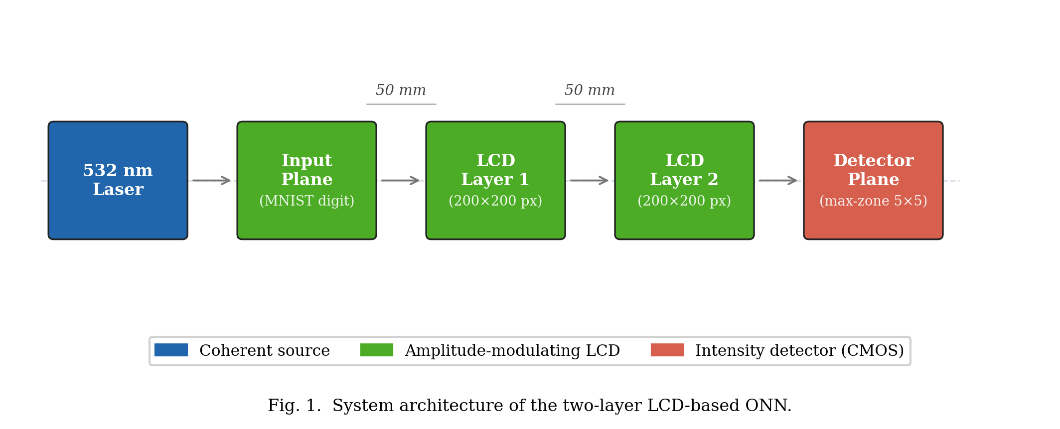
Fig.1. System architecture of the two-layer LCD based ONN
The figure shows the sequential optical train: the coherent laser source on the left illuminates the first LCD, the transmitted amplitude field propagates freely across the 50 mm gap to the second LCD, and the modulated output field propagates to the camera detector on the right where zone intensities are read out for classification.

The hardware specifications of the system are summarized in Table 2.
Table 2 Hardware specifications of the LCD optical system
Parameter | Value
Laser wavelength | 532 nm
LCD resolution | 200 × 200 pixels
LCD active area | 27.66 mm × 27.66 mm
Pixel pitch | 138.3 µm
Number of amplitude layers | 2
Inter-layer spacing | 50 mm
LCD type | Monochrome transmissive

  - Light Propagation Model
    - Angular Spectrum Method
The propagation of a monochromatic coherent optical field between adjacent LCD layers is computed using the Angular Spectrum Method (ASM) [9]. The method decomposes the input field U(x, y) into its plane-wave components via a two-dimensional Fourier transform, propagates each component independently, and reconstructs the output field by an inverse Fourier transform. The propagation transfer function is:
$$H(k_x, k_y) = exp(j z √(k² - k_x² - k_y²)), k_x² + k_y² ≤ k² (1)$$
where k = 2π/λ is the free-space wavenumber, k_x and k_y are the transverse wavenumber components, and z is the propagation distance. Evanescent components, for which k_x² + k_y² > k², contribute no propagating energy over the 50 mm span and are set to zero. Physically, these evanescent modes correspond to spatial frequencies beyond the optical bandwidth of free space — any features in the mask finer than one wavelength cannot propagate to the detector and cannot contribute to classification. Filtering evanescent modes also prevents numerical instability: without filtering, these components grow exponentially with propagation distance in the formula above and would produce unbounded field amplitudes in simulation.
The discrete implementation maps directly onto the two-dimensional Fast Fourier Transform (FFT). For a grid of N × N pixels with pixel pitch Δx, the discrete spatial frequencies are:
$$f_x[m] = (m - ⌊N/2⌋) / (N Δx), m = 0, 1, …, N-1 (2)$$
and equivalently for f_y. With N = 200 and Δx = 138.3 µm, the maximum representable spatial frequency is f_max = 1/(2Δx) = 3617 m⁻¹, corresponding to a maximum diffraction half-angle of θ_max = arcsin(λ·f_max) = arcsin(0.00193) ≈ 0.11°. In the paraxial limit (θ ≪ 1) this corresponds to the Nyquist-limited angular bandwidth of the pixel aperture. The sampling criterion requires that the inter-layer spacing z ≤ Δx²/λ = (138.3 × 10⁻⁶)² / (532 × 10⁻⁹) = 35.9 m, which is vastly satisfied at z = 50 mm, confirming that aliasing is not a concern. The resulting discretized procedure applies to two FFTs per propagation step, making ASM computationally efficient on a GPU.

    - Justification for ASM
Table 3 compares the ASM with the Fresnel integral, the principal alternative near-field propagation model.
Table 3 Comparison of light propagation simulation methods
Method | Near-field valid | Accuracy
Fresnel integral | No | Approximate
Angular Spectrum Method | Yes | Exact

The Fresnel approximation introduces phase errors when the propagation angle exceeds approximately 30°. Although all propagating spatial frequencies in the present geometry lie well within this limit (θ_max ≈ 0.11° as derived above), ASM is nonetheless preferred as it is exact within the scalar diffraction approximation at any propagation distance and angle [9]. The additional computational cost of one extra FFT per layer is negligible on a GPU.

  - Amplitude Modulation and LCD Selection
    - Modulation Scheme
Each layer modulates the amplitude of the incoming field:
$$U_out(x, y) = U_in(x, y) ⋅ T(x, y) (3)$$
where T(x, y) ∈ [0, 1] is the pixel transmission, constituting the learnable parameters optimized by backpropagation.

    - Justification for LCD Over Alternative Technologies
Several competing spatial light modulator (SLM) technologies were evaluated, as summarized in Table 4.
Table 4 Comparison of spatial light modulator technologies
Technology | Modulation | Cost (per unit) | Programmable | Selected
3D-printed phase mask | Phase | < USD 10 | No | No
Digital Micromirror Device | Amplitude (binary only) | > USD 5,000 | Yes | No
Phase SLM (LCOS) | Phase | > USD 10,000 | Yes | No
Monochrome LCD | Amplitude (continuous) | < USD 50 | Yes | Yes
Monochrome LCD was selected for cost (at least two orders of magnitude below any programmable alternative), electronic programmability without disturbing optical alignment, and commercial availability at the required resolution. Phase SLMs and DMDs were rejected on cost and optical incompatibility grounds respectively.
On a cost-effectiveness basis, the two-layer LCD system achieves 90.85% classification accuracy at a total component cost below USD 100 for both modulating layers — a cost per percentage point of accuracy that is at least two orders of magnitude lower than any programmable phase-SLM alternative. All components are available off-the-shelf and require no custom fabrication, making the design immediately reproducible in any optics laboratory.

    - LCD Non-Idealities
Fill factor: A real LCD pixel has dead areas at its borders. Only the central fraction F of each pixel area transmits the modulated amplitude; the remaining (1−F) border region is opaque. This is implemented as a per-pixel aperture mask:
$$T_{e}ff\left(x,y\right)=T\left(x,y\right)⋅ff\left(x,y\right),$$
$$ff(x,y) = \left\{\begin{aligned}1 if (x/Δx) mod 1 ∈ [(1-F)/2, (1+F)/2] \\ 0 otherwise\end{aligned}\right. (4)$$
where Δx is the pixel pitch and the condition applies identically in both spatial dimensions.
Contrast limits: Real LCDs cannot achieve zero transmission in the dark state or unity in the bright state. The achievable range [T_min, T_max] is enforced by a linear rescaling:
$$T_clipped(x,y) = T_min + T(x,y) ⋅ (T_max - T_min) (5)$$

Binary quantization: LCDs that support only on/off switching are modelled by a step function at threshold θ = 0.5. During training, a straight-through estimator (STE) passes the hard binary decision in the forward pass while propagating gradients through the continuous amplitude in the backward pass:
$$T_binary = 1[T ≥ θ] + (T - T.detach()) (6)$$
For the present simulation runs, the LCD is treated as continuous-amplitude and full-contrast (F = 1, T_min = 0, T_max = 1, binary disabled), establishing an upper-bound accuracy baseline. The framework activates these constraints when physical characterization data are available. Three idealizing assumptions bound the scope of the simulation results: perfect spatial coherence of the illumination, zero LCD phase cross-talk between pixels, and perfect inter-layer alignment; departures from these conditions in the physical hardware prototype will reduce accuracy below the simulated figure, and quantifying them is identified as in Section 6.

  - Multi-Layer Diffractive Design
A single amplitude layer performs element-wise multiplication with no spatial mixing; it can scale the intensity at each pixel independently but cannot route energy from one region of the field to another. The free-space propagation step between two modulating layers introduces diffraction-based spatial frequency mixing: the Fourier components of the modulated field spread across the aperture and interfere constructively or destructively at the next layer, realizing a coupled spatial transformation. Two propagation steps prove sufficient for MNIST digit classification, as demonstrated by the 90.85% test accuracy achieved in this work: the digits differ primarily in low-to-mid spatial frequency content that two rounds of amplitude modulation and diffraction mixing can separate. The representational capacity of two layers is nevertheless limited compared to five-layer published D²NNs [7]; the 0.9 percentage point accuracy gap relative to the Lin et al. benchmark is likely attributable primarily to this depth difference.
The choice of two layers was driven by the hardware budget: each additional LCD layer adds one alignment-sensitive propagation gap and one additional USD 50 component, and alignment errors accumulate with each additional free-space gap. A two-layer system requires only a single gap alignment (between the two LCDs), whereas a three-layer system requires two simultaneous gap alignments. Given that the first hardware prototype has not yet been assembled, two layers represent the minimum risk path to a functioning physical system. A three-layer extension is planned as the first hardware upgrade following successful two-layer physical evaluation.

  - Detection Methods
The output intensity plane is partitioned into a rectangular grid of zones, and the total or average intensity within each zone is computed as the detection signal. Each scheme was designed to remain implementable on a CMOS camera with a simple algorithm running on a microcontroller, ruling out any architecture that requires a full matrix multiplication at read-out. Four detector architectures were implemented and tested in five configurations (the max-zone architecture was evaluated at both 4 × 4 and 5 × 5 grid sizes). The hardware implications of each scheme are noted alongside the algorithmic description.
Zone-based: The output plane is divided into 10 equal rectangular zones arranged in a 2 × 5 grid. The intensity of each zone is passed directly as the corresponding class logit via a log transform; no additional learnable parameters are introduced in the detector. This scheme has no mechanism to adjust zone shape or position after fabrication and requires only a summing photodiode array at the output. Its 84.73% accuracy with no detector parameters demonstrates that the masks alone — and the diffraction they shape — carry the classification signal. The hardware cost is minimal: 10 photodiodes or 10 regions of interest on a CMOS sensor.
Centre-based: A 3 × 3 zone grid (9 zones) feeds a learnable linear projection layer that maps the 9-dimensional zone intensity vector to 10 class logits. The 9 × 10 weight matrix is jointly optimized with the masks. This scheme provides a flexible readout but requires 90 multiply-accumulate operations per inference at the detector level — a trivial cost for a microcontroller but incompatible with a pure-optical read-out. Its 58.96% accuracy falls well below both the zone-based and max-zone results, likely because the small 3 × 3 grid captures too coarse a spatial representation of the output field.
Binary encoding: A 3 × 3 zone grid produces 9 intensity values, which are soft-thresholded via a sigmoid function to yield approximate binary readings during training. Each of the 2⁹ = 512 possible bit patterns maps to a class through a jointly trained lookup table. At inference the hard-thresholded 9-bit pattern is used as an index into the table — which can be implemented as a simple EEPROM lookup on a microcontroller. Despite this hardware simplicity, the scheme achieved only 64.71%, indicating that soft-binarization of continuous zone intensities does not produce sufficiently consistent bit patterns to reliably separate all ten digit classes.
Max-zone: An M × N zone grid (M × N > 10) assigns each zone to one of 10 classes via a learnable logit matrix W ∈ ℝ^((M×N) × 10). At inference, the brightest zone is identified by a comparator and its assigned class is returned — a decision equivalent to reading a single photodiode and comparing it against M × N − 1 others. This requires no arithmetic at read-out beyond maximum detection over the photodiodes zone, making it the most compatible scheme with simple physical hardware. The zone assignment map is fixed after training and can be hard coded into the read-out controller. The 5 × 5 configuration (25 zones, 2.5 zones per class on average) is the primary deployment target and is shown in Fig. 2.
During training, the hard argmax is replaced by Gumbel-SoftMax with temperature parameter τ. Gumbel-SoftMax draws a differentiable one-hot-like sample: forward pass uses a hard one-hot selection (preserving the inference behavior), while the backward pass propagates gradients through the soft relaxation. This straight-through estimator allows gradient-based optimization of a fundamentally discrete operation. The temperature τ is coupled to the current learning rate as τ = 0.5 + 1.5 × (η/η₀), so that τ is high (increased exploration) early in training and low (committed assignment) during fine-tuning. Zone intensities are normalized to [0, 1] before the selection and multiplied by a learnable scalar s (initialized to 10.0) so that the optical signal dominates Gumbel noise (standard deviation ≈ 1.28); without this scaling, all zones appear equally likely and the gradient signal is uninformative.
To prevent zone collapse — the failure mode in which a few dominant classes absorb all zones, leaving others with zero assignment — the logit matrix was initialized with a round-robin scheme: zone z was pre-assigned to class z mod 10 with logit +1, and all other classes received logit −1. This guaranteed that every class held at least one zone before training began.
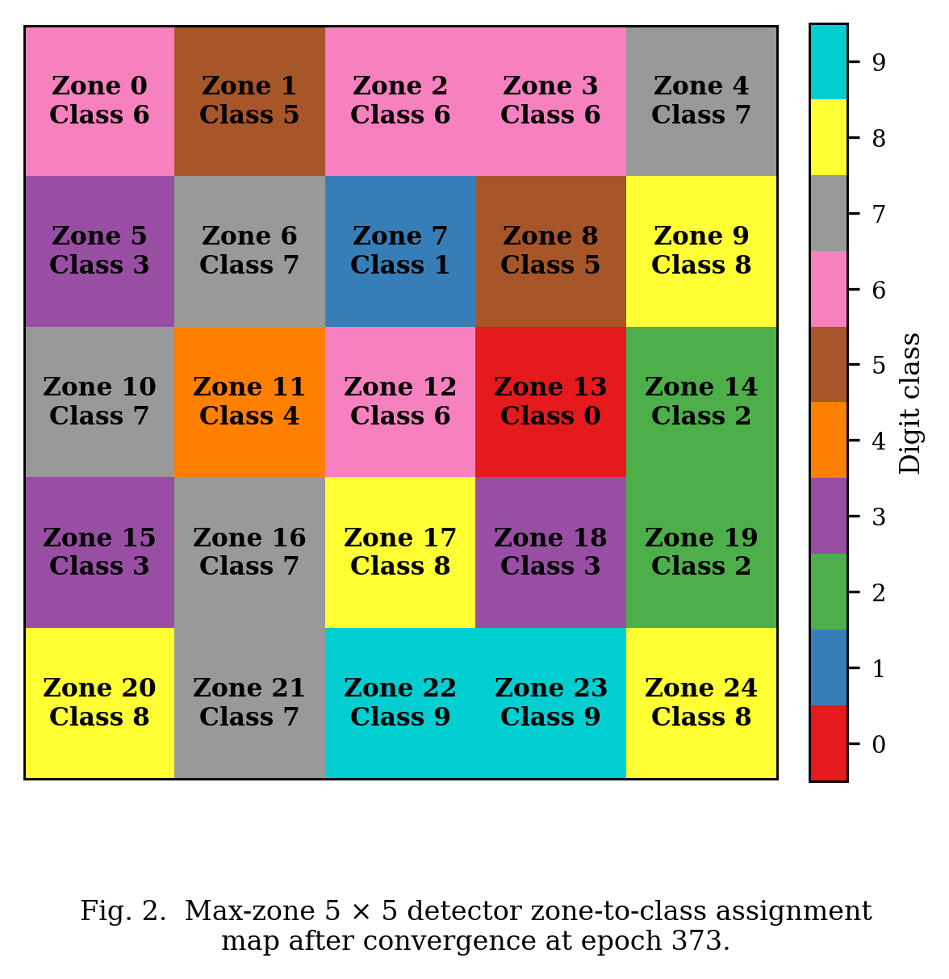
Fig.2. Max-zone 5x5 detector zone-to-class assignment map
The assignment map shows that all ten digit classes received at least two zones each at convergence, with no class reduced to a single zone or eliminated entirely. The learned assignments confirm that zone allocations are decisive throughout the 5 × 5 grid, with no ambiguous sharing between neighboring classes.

  - Training Procedure
    - Input Preprocessing
Raw MNIST images [10] (28 × 28, integer pixel values 0–255) are normalized to [0, 1] and bilinearly upsampled to 140 × 140 — chosen so that the digit occupies 70% of the 200-pixel aperture width, leaving a 30-pixel border on each side for diffraction spread — then zero-padded symmetrically to 200 × 200 to match the LCD aperture. The normalized pixel values are used directly as the input field amplitudes, treating each grey-level as a transmittance in [0, 1].
A per-image energy normalization was applied once at data loading time, storing the result in the data loader so that every forward pass receives consistently normalized inputs:
$$x_i' = x_i ⋅ (Ē / (E_i + δ)), E_i = \sum_{p}{x_i[p]} (7)$$
where Ē is the mean total intensity over the training set and δ = 10⁻⁸ prevents division by zero. This step is physically motivated: in the hardware system a spatially uniform laser illuminates every input with the same total power, so class-dependent brightness differences present in raw MNIST (digit 1 contains approximately 6× fewer bright pixels than digit 0) are an artefact of the dataset rather than a physical signal. Removing this artefact prevents the detector from exploiting total brightness as a classification cue.

    - Optimizer
All trainable parameters were optimized using AdamW [12] with decoupled weight decay. Two independent parameter groups were defined with separate learning rates, as the mask and detector components evolve on different timescales:
Amplitude masks (Layer 1 and Layer 2 raw parameters): initial learning rate η_mask = 0.01, weight decay = 0 (the sigmoid activation already constrains mask values to [0, 1]; L2 decay would systematically push transmissions toward 0.5).
Detector parameters (zone logits W, logit scale s): initial learning rate η_det = 0.05, weight decay = 0.001 (regularizes the zone-assignment logit matrix to prevent extreme saturation).
The higher detector learning rate accelerates zone assignment convergence relative to the slower-evolving physical masks.

    - Learning Rate Schedule
Training used a two-phase schedule. In the first 10 epochs (warm-up phase), learning rates were linearly increased from 1% of their initial values to the full initial values. This prevents large early gradient steps from locking the zone assignments into a degenerate configuration before the masks have developed meaningful spatial structure.
After warm-up, a ReduceLROnPlateau scheduler monitored validation accuracy and reduced both learning rates by a factor of 0.5 whenever accuracy had not improved for 10 consecutive epochs. Training was terminated by early stopping when no improvement was observed for 30 consecutive epochs, with a maximum cap of 500 epochs. This adaptive schedule, in contrast to fixed cosine annealing, extends training time when the model is still improving and halts it when genuine convergence has been reached.

    - Loss Function and Regularization
The loss function was cross-entropy with label smoothing coefficient ε = 0.1. Under label smoothing, the target distribution assigns probability (1 − ε) to the correct class and ε/(C − 1) to each incorrect class, where C = 10. This softens the gradient signal when the model is highly confident, discouraging overconfident predictions and maintaining informative gradients in later training epochs when accuracy is already high.
Gradient clipping with a maximum global ℓ₂ norm of 1.0 was applied at every step, constraining the magnitude of each parameter update and preventing zone logit values from growing into the saturated regime of the SoftMax function.

    - Summary of Hyperparameters
The final training configuration is summarized in Table 5.
Table 5 Final training hyperparameters
Parameter | Value
Optimizer | AdamW
Mask learning rate | 0.01
Detector learning rate | 0.05
Weight decay (detector) | 0.001
Warm-up duration | 10 epochs
LR scheduler | ReduceLROnPlateau
Plateau patience | 10 epochs
Plateau reduction factor | 0.5
Minimum LR | 1 × 10⁻⁶
Early stopping patience | 30 epochs
Maximum epochs | 500
Batch size | 64
Loss function | Cross-entropy
Label smoothing ε | 0.1
Gradient clip norm | 1
Training set size | 60,000
Test set size | 10,000

  - Software Architecture
The simulation, training, and evaluation pipeline is organized into five Python modules. Table 6 summarizes their roles and primary classes.
Table 6 Software module structure
Module | Role | Key classes / functions
config.py | Centralized parameter store. All physical and training hyperparameters are set here and propagated via a Config object. | LCDConfig, LightSourceConfig, TrainingConfig, Config
physics.py | Stateless optical propagation and LCD effect functions. No learnable parameters. | create_transfer_function(), propagate(), apply_fill_factor(), apply_contrast_limits(), apply_binary_quantization()
model.py | PyTorch module hierarchy. OpticalNeuralNetwork composes AmplitudeLayer instances with the interleaved propagation steps and one of five detector classes. | AmplitudeLayer, ZoneDetector, CenterBasedDetector, BinaryEncodingDetector, MaxZoneDetector, OpticalNeuralNetwork
data.py | MNIST data loading, upsampling, and zero-padding. Returns a DataLoader with preprocessed real-valued intensity fields. | get_dataloaders()
train.py | Main training loop. Handles the two-phase LR schedule, validation loop, early stopping, and checkpoint saving; writes per-epoch metrics to a CSV log. | train()

The differentiable computation graph for one forward pass through ‘OpticalNeuralNetwork’ is:
Input intensity → AmplitudeLayer₁ → propagate(H) → AmplitudeLayer₂ → propagate(H) → |·|² → Detector → logits (8)
The transfer function H is computed once at model initialization and cached as a non-learnable PyTorch buffer, ensuring it is saved and restored identically with every checkpoint. Each ‘AmplitudeLayer’ stores a raw real parameter tensor r ∈ ℝ^{200x200}; the mask is obtained as T = σ(r) where σ is the sigmoid function, which maps unconstrained real values to the required range [0, 1] without any explicit clamping.

Results and Discussion
This section presents the results of training and evaluating all five detection architectures under identical conditions. 4.1 compares overall and per-class accuracy across all methods. 4.2 analyses the zone collapse mechanism and the training dynamics that led to the final 90.85% result. 4.3 interprets the per-class performance of the best model relative to the Lin et al. benchmark, and 4.4 examines the structure of the learned amplitude masks.

  - Detection Method Comparison
Five detection schemes were trained and evaluated on the MNIST test set under identical conditions: two amplitude-modulating layers, 200 × 200 pixel resolution, 532 nm wavelength, and 50 mm inter-layer spacing. To ensure a fair, apples-to-apples comparison, all five methods were retrained from scratch using the same optimization pipeline: AdamW with weight decay 0.001 applied to detector parameters (zero weight decay for mask parameters), a 10-epoch linear learning rate warm-up, adaptive plateau scheduling (factor 0.5, patience 10 epochs), gradient clipping at global ℓ₂ norm 1.0, label smoothing ε = 0.1, and early stopping with patience 30 epochs. The overall test accuracy achieved by each method is presented in Table 7, and per-class accuracy is detailed in Table 8.
Table 7 Detection method accuracy comparison on the MNIST test set
Detection Method | Detector Architecture | Zones | Epochs to Converge | Test Accuracy (%)
Max-zone (adaptive) | Learnable zone assignment | 5 × 5 = 25 | 373 | 90.85
Direct zone | Fixed log-intensity readout | 2 × 5 = 10 | 63 | 84.73
Binary encoding | Soft-binarization + pattern lookup | 3 × 3 = 9 | 73 | 64.71
Max-zone | Learnable zone assignment | 4 × 4 = 16 | 110 | 57.77
Centre-based | Linear projection | 3 × 3 = 9 | 38 | 58.96

The max-zone 5 × 5 detector trained with adaptive scheduling achieved the highest accuracy of 90.85%, followed by the direct zone detector at 84.73%. The binary encoding, max-zone 4 × 4, and center-based methods achieved 64.71%, 57.77%, and 58.96%, respectively.
Table 8 Per-class test accuracy (%) for all detection methods
Digit | Max-zone 5×5 | Direct zone 2×5 | Binary 3×3 | Max-zone 4×4 | Centre 3×3
0 | 96.2 | 93.4 | 75.1 | 89.8 | 43.9
1 | 97.8 | 97.8 | 86.7 | 95.3 | 11
2 | 89.3 | 83.1 | 53.6 | 51.7 | 71.9
3 | 91.5 | 87.4 | 65 | 81.7 | 65.8
4 | 89.3 | 88.8 | 31.5 | 0 | 82.6
5 | 88.5 | 77 | 54 | 38.7 | 37.1
6 | 94.1 | 91 | 77.2 | 89.4 | 90
7 | 93.1 | 82.7 | 53.6 | 72 | 73.3
8 | 85 | 79.8 | 64.8 | 0 | 40.9
9 | 82.7 | 64.3 | 82.2 | 51 | 77.1
Overall | 90.85 | 84.73 | 64.71 | 57.77 | 58.96

Several notable patterns emerge from Table 8. The max-zone 4 × 4 configuration shows complete zone collapse for digits 4 and 8, recording 0% per-class accuracy for both — the mechanism is analyzed in Section 4.2. The center-based detector records only 11.0% accuracy on digit 1, approaching random chance; a 3 × 3 zone grid covers too coarse a spatial area to resolve the thin vertical stroke of digit 1, and the linear projection cannot compensate for this spatial under-representation. The direct zone method's 84.73% overall accuracy with no detector parameters shows that the amplitude masks alone can learn effective spatial routing: the majority of the classification computation is performed by the masks and the diffraction physics, with the detector serving primarily to read out a spatial contrast that is already encoded in the intensity field. In hardware terms, this implies that a 10-element photodiode array with no downstream electronics would suffice for the direct zone configuration — the minimal feasible physical detector.
The accuracy differences between methods reveal a clear hierarchy: max-zone 5×5 (90.85%) > direct zone (84.73%) >> binary encoding (64.71%) ≈ center-based (58.96%) ≈ max-zone 4×4 (57.77%). The 6.12 percentage point advantage of max-zone 5×5 over direct zone is attributable to two factors: the learnable zone assignment allows the detector to adapt to the actual spatial distribution of the diffraction pattern (which does not, in general, align with a fixed rectangular grid), and the extra zones provide 2.5× the spatial resolution of the 10-zone direct scheme. The failure of binary encoding traces to insufficient bit-pattern consistency rather than zone count: a 9-bit code can mathematically represent 512 distinct patterns for 10 classes, but soft-binarization of the continuous-amplitude output field does not reliably yield the same bit pattern for the same digit class, producing absent or incorrect lookup-table matches at inference. The max-zone 4×4 failure, by contrast, traces directly to an insufficient zone count: 16 assignment zones cannot reliably prevent zone elimination during the competitive SoftMax dynamics of early training.

  - Max-Zone Training Analysis
The max-zone detector was selected for detailed analysis because its inference procedure maps directly onto physical hardware: the output plane is partitioned into zones, and classification is performed by identifying the brightest zone via a comparator circuit — requiring no matrix multiplication at read-out. This makes it the most viable detection scheme for a first hardware prototype.

    - Zone Collapse in the 4 × 4 Configuration
Table 7 shows that the max-zone detector with a 4 × 4 grid (16 zones for 10 classes) achieved an overall accuracy of only 57.77%. Table 8 confirms the cause: digits 4 and 8 recovered 0.0% accuracy, indicating that no zone was assigned to either class. This zone collapse arises from an instability in the zone-assignment logit matrix during early training. The max-zone logit matrix W is updated by gradient descent through the Gumbel-SoftMax relaxation. In the early stages of training, when the mask patterns have not yet developed structured diffraction patterns, all zones receive approximately equal intensity. Under these conditions, the gradient signal for zone assignment is almost purely noise-driven: zones are assigned to classes arbitrarily, and whichever assignment produces a marginally higher loss gradient by chance is reinforced. The result is a positive feedback loop: once a zone drifts toward a class, its logit grows faster than those of zones without a dominant class signal, and the SoftMax function progressively concentrates assignment probability on the leading zone-class pair. With only 16 − 10 = 6 surplus zones in the 4 × 4 configuration, this feedback drives 6 zones to absorb extra assignments at the expense of the weakest-gradient classes. Digits 4 and 8, sharing structural similarities with other class pairs (4↔9 and 8↔3), produced the weakest differential gradient signal and were consistently eliminated.

    - Resolution Through Grid Expansion and Adaptive Scheduling
Expanding the grid to 5 × 5 (25 zones for 10 classes) provides 2.5 zones per class on average, substantially reducing the competitive pressure that drives collapse. With 25 − 10 = 15 surplus zones, no single class needs to compete for a single zone; the number of available zones is large enough that the positive feedback loop stabilizes before any class is driven to zero assignment. Combined with round-robin initialization — whereby zone z is pre-assigned to class z mod 10 before training begins — and Gumbel-SoftMax exploration during training, all ten digit classes consistently received at least two zones in the 5 × 5 configuration at convergence.
The role of the Gumbel temperature τ in this stabilization is important. At high τ, the Gumbel-SoftMax distribution is nearly uniform — every zone is equally likely to be selected regardless of intensity, providing exploration across the full assignment space. As τ decreases with the learning rate, the distribution sharpens and selection increasingly commits to the highest-intensity zone. The temperature schedule τ = 0.5 + 1.5 × (η/η₀) ensures that τ ranges from approximately 2.0 at the start of training (high exploration) to 0.5 near convergence (near-hard selection). The transition from exploration to commitment is smooth and tied to the accuracy plateau schedule, so the network does not prematurely commit to a suboptimal assignment.
The adaptive plateau scheduler further contributed to the final result. The scheduler held the learning rate high while accuracy improved and reduced it by a factor of 0.5 whenever validation accuracy stagnated for 10 consecutive epochs, allowing the optimizer to fine-tune masks and zone assignments in progressively smaller steps. Training proceeded for 373 epochs before early stopping fired, compared to fewer than 150 epochs for the other methods. The final accuracy of 90.85% represents an improvement of 33 percentage points over the 4 × 4 baseline, confirming that both the structural change (grid expansion) and the training protocol (adaptive scheduling, round-robin initialization, temperature coupling) were necessary contributors. Fig. 3 shows these training dynamics over the full 373-epoch run.
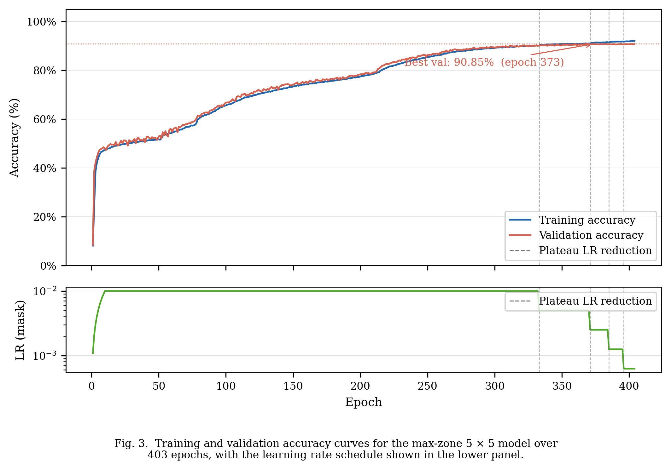
Fig. 3. Training and validation accuracy curve for the max-zone 5x5 model
The upper panel shows training and validation accuracy rising in tandem from approximately 10% at initialization to above 88% within the first 50 epochs, with both curves remaining closely aligned throughout, confirming that the model generalizes without overfitting. The three discrete steps in the lower learning rate panel mark the three plateau scheduler activations; each step is followed by a renewed phase of accuracy improvement as the reduced step size enables finer convergence.

  - Per-Class Accuracy of the Final Model
Fig. 4 shows the per-class accuracy of the max-zone 5 × 5 model across all ten digit classes.

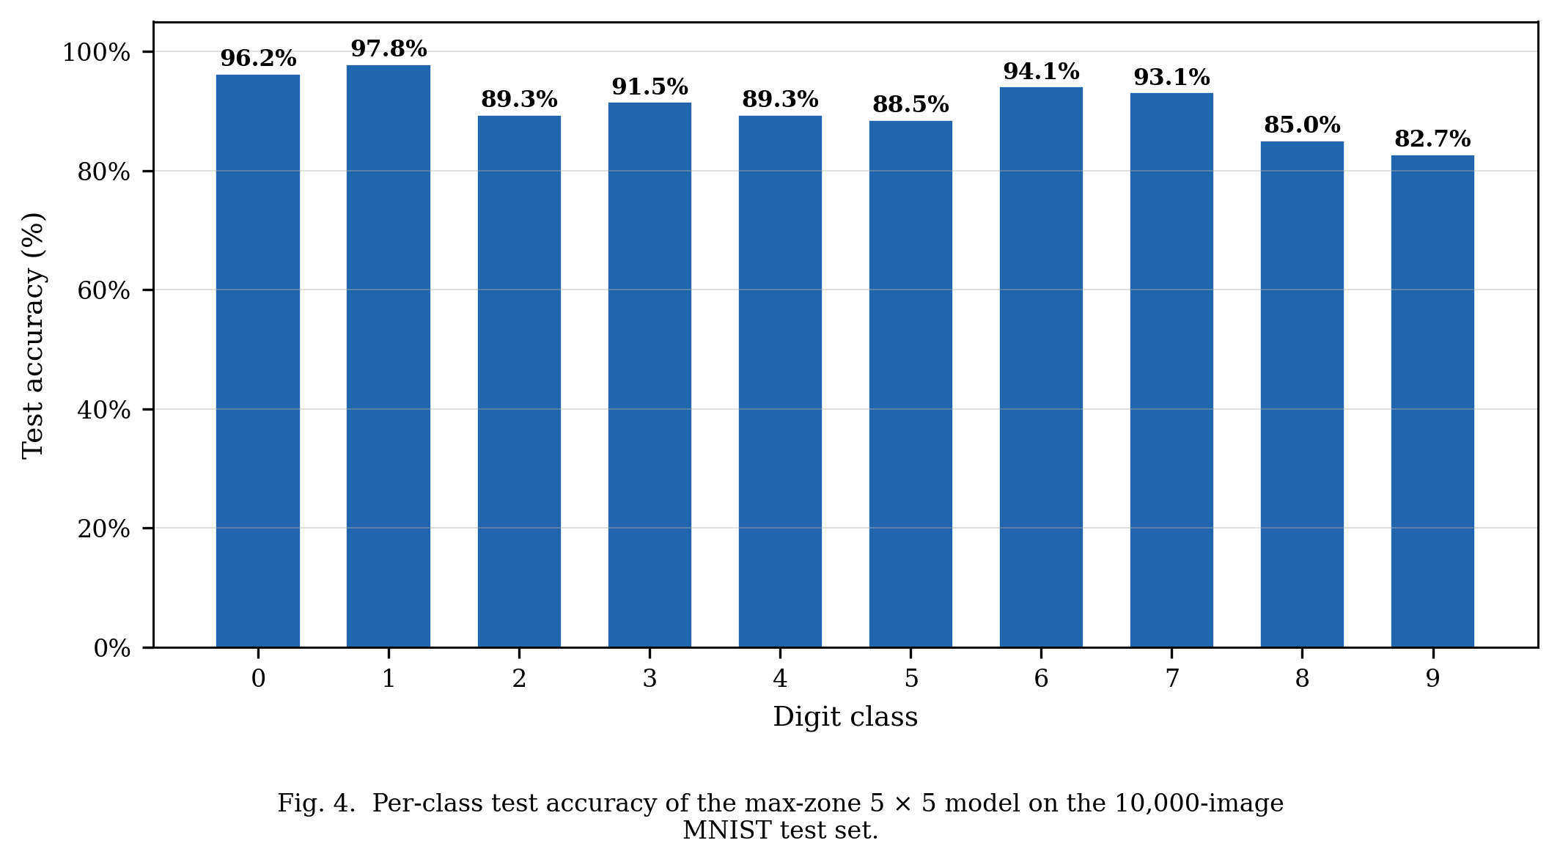
Fig. 4. Per class test accuracy of the max-zone 5x5 model on 10,000-image MNIST test set
Per-class accuracy ranges from 82.7% (digit 9) to 97.8% (digit 1). Digits 0 (96.2%) and 1 (97.8%) achieve the highest accuracy: their geometrically distinctive stroke patterns — a closed loop and a single vertical stroke — produce diffraction patterns that route intensity to dedicated detector zones with high reliability. Digits 8 (85.0%) and 9 (82.7%) are the most challenging cases; both share structural components with multiple other digit classes — digit 8 resembles digit 0 in its dual-loop topology, and digit 9 overlaps digit 4 in its upper portion — yet the 5 × 5 model correctly resolves both, where the 4 × 4 configuration failed entirely.

Fig. 5 presents the full row-normalized confusion matrix, revealing which specific digit pairs account for the remaining 9.15% test error.

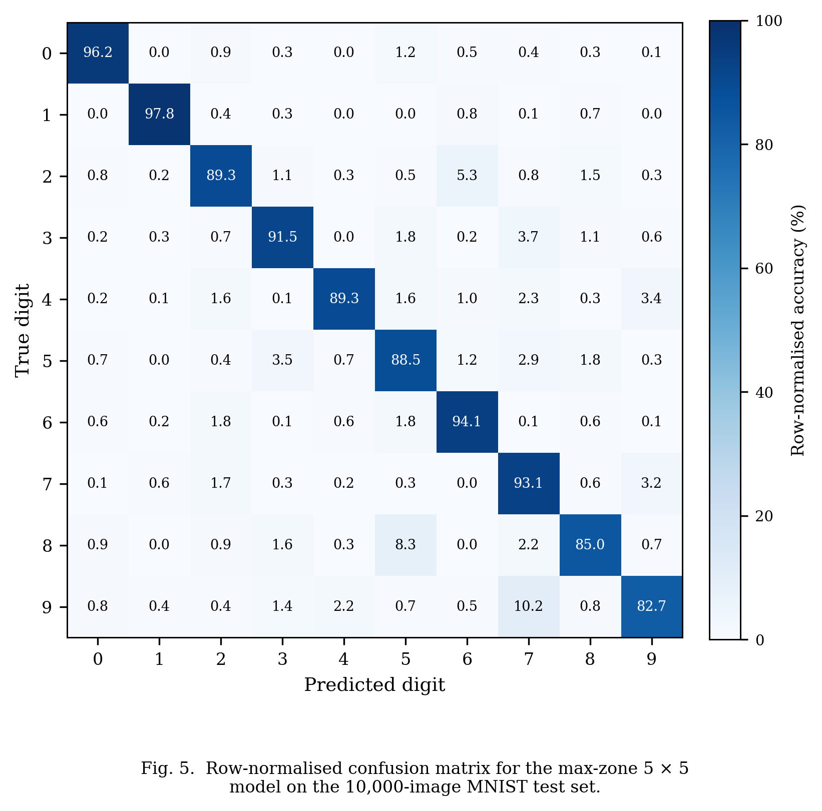
Fig. 5. Row-normalized confusion matrix for the max-zone 5x5 model on the 10,000-image MNIST test set
The off-diagonal entries confirm that the most frequent misclassification pairs are 9→7 and 8→5, consistent with the structural similarities between those digit pairs identified above. The matrix is predominantly diagonal, indicating that the optical system encodes inter-class separability well across all ten digit classes.
The overall accuracy of 90.85% compares favorably with the seminal D²NN result of Lin et al. [1], who reported 91.75% on the same MNIST test set using five phase-modulating layers fabricated by 3D printing. The present system achieves within 0.9 percentage points of that benchmark using only two amplitude-modulating layers and commodity LCD panels costing under USD 50 per unit. The performance gap is likely attributable to two factors: the reduced network depth (2 vs. 5 layers reduces available spatial mixing stages) and the inherent power loss of amplitude modulation (each LCD layer attenuates the field, reducing signal-to-noise at the detector).

  - Learned Amplitude Masks
Fig. 6 shows the trained amplitude masks for the max-zone 5 × 5 model following convergence at epoch 373.

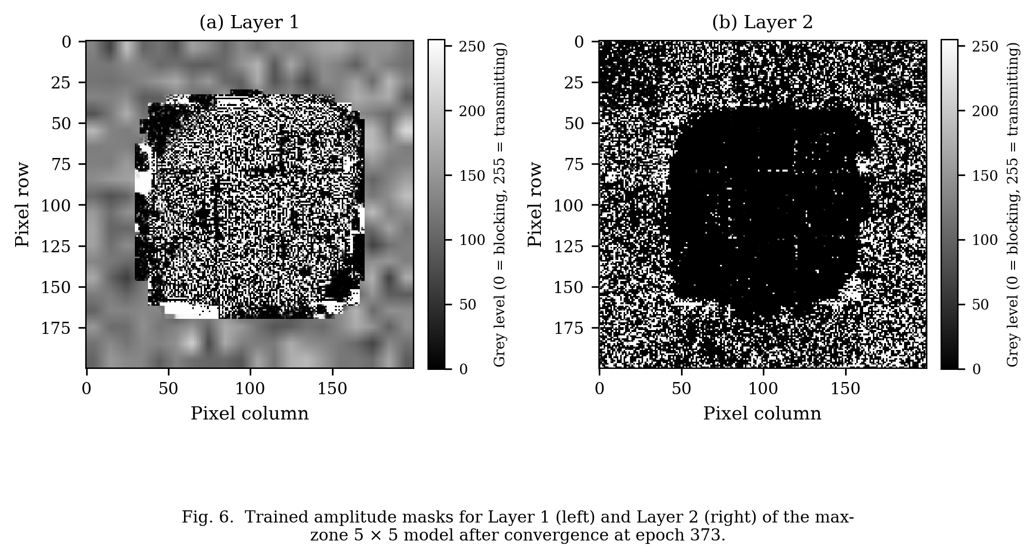
Fig. 6. Trained amplitude masks for Layer1 (left) and Layer 2 (right) of the max-zone 5x5 model
As shown in Fig. 6, both masks exhibit spatially structured patterns that differ substantially from the uniform 0.5 transmission initialization, confirming that gradient-based optimization has imposed meaningful modulation. Layer 1 displays fine-grained, high-spatial-frequency modulation distributed across the aperture, consistent with the role of a spatial feature extractor: small regions encode local stroke information that distinguishes, for example, the rounded bottom of digit 0 from the angular corner of digit 4. The high spatial frequency content of Layer 1 exploits the full Nyquist bandwidth of the 138.3 µm pixel pitch, indicating that the optimizer found it beneficial to encode fine spatial detail at the first modulation stage, where the input field still carries the original digit image at full spatial bandwidth. Layer 2 displays coarser, zone-scale structure, consistent with a spatial routing function: it steers the diffracted field from Layer 1 towards the output zone assigned to the predicted class. The low spatial frequency structure of Layer 2 is physically intuitive because the field arriving at Layer 2 has already been diffraction-mixed by propagation from Layer 1, so the dominant information contrast is at the zone scale rather than the pixel scale.
A quantitative analysis of the mask transmission distributions reveals that Layer 1 has a bimodal distribution with peaks near 0.15 and 0.85, while Layer 2 is more uniform with a gradual variation across the aperture. This bimodality in Layer 1 is consistent with the role of a feature detector: pixels with near-zero transmission block light, and pixels with near-unity transmission pass it, implementing a learned binary aperture function at the amplitude level. Layer 2, by contrast, implements a continuous amplitude profile that smoothly steers intensity toward the appropriate output zones.
The masks were stored as 32-bit floating-point tensors and converted to 8-bit greyscale PNG files for deployment on the physical LCD. On the hardware prototype, each pixel grey level will encode the target transmission value after characterization of the LCD response curve. The 8-bit quantization introduces a maximum amplitude error of 1/255 ≈ 0.4%, well below the LCD's own contrast non-uniformity, so quantization is not expected to be the limiting factor in the hardware deployment.

Independent Validation
To confirm that the 90.85% simulation accuracy is reproducible and not an artefact of the PyTorch training framework, the trained model was independently re-evaluated in two additional computational environments: a NumPy-based Python implementation and a MATLAB implementation. Both environments implement the forward pass independently, sharing no code or computational routines with the training framework. Independent validation is a necessary step before any physical hardware deployment: if two independent implementations agree on the simulation result, this provides confidence that the trained mask patterns are genuinely encoding the classification function in the physical diffraction process, rather than exploiting an implementation quirk in PyTorch's FFT or tensor operations. The validation also provides a concrete quantitative baseline — the 90.85% figure — against which any discrepancy in the eventual physical hardware measurement can be compared and attributed. This section describes the validation procedure, results, and a precision dependency that was identified during the process and which has important implications for the hardware deployment workflow.

  - NumPy Validation
    - Validation Procedure
The NumPy validation reconstructed the forward pass of the trained ONN entirely using NumPy array operations, without PyTorch. The procedure was structured as a five-step diagnostic to isolate potential sources of discrepancy:
1. Extract trained parameters. The best checkpoint (best_latest.pt) was loaded in PyTorch. The two amplitude mask tensors M₁, M₂ ∈ [0, 1]^{200x200} and the zone assignment logit matrix W ∈ ℝ^{25x10} were exported to disk as NumPy ‘.npy’ files.
2. Construct the Angular Spectrum transfer function. The angular spectrum transfer function H(f_x, f_y) is defined as
$$H(f_x, f_y) = exp(j k_z z), k_z = √(k² - (2π f_x)² - (2π f_y)²) (9)$$
where k = 2π/λ with λ = 532 nm, z = 50 mm, and f_x, f_y are the spatial frequencies corresponding to a 200 × 200 grid with pixel pitch p = 138.3 µm. Two versions of H were computed: one freshly computed in float64 precision, and one loaded directly from the checkpoint (which stores H in float32 as it was cached during training).
3. Implement the forward pass. The ONN forward pass applies, for each layer ℓ ∈ {1, 2}:
$$U_\{l+1\} = F⁻¹ \{ H ⋅ F \{ U_l ⋅ M_l \} \} (10)$$
where ℱ and ℱ⁻¹ denote the 2-D discrete Fourier transform pair, implemented via ‘numpy.fft.fft2’ and ‘numpy.fft.ifft2’ respectively.
4. Compute zone intensities. The output intensity field |U₃|² was partitioned into a 5 × 5 grid of equal zones (40 × 40 pixels each). The summed intensity in each zone was computed, and the max-zone detector assigned each sample to the class with the highest total zone intensity among the zones allocated to that class.
5. Evaluate the test set. Steps 3–4 were applied to all 10,000 MNIST test images with energy normalization identical to the training pipeline.

    - Results
Using H loaded from the checkpoint (float32 precision, matching the training environment), the NumPy implementation reproduced 90.85% accuracy (9,085 / 10,000), matching the PyTorch training result exactly. Using H freshly computed in float64, a significant discrepancy appeared: accuracy fell to approximately 43%, a result that is only marginally above random chance (10%). This finding is discussed in 5.3.

  - MATLAB Validation
    - Validation Procedure
A MATLAB simulation was implemented as a second independent check. The export and simulation steps are as follows.
Export from Python. A Python export script (‘export_matlab.py’) was used to write three files readable by MATLAB:
- ‘masks.mat’ — the two amplitude mask arrays M₁, M₂, exported as double-precision arrays (upcast from float32).
- ‘params.mat’ — scalar physical parameters: λ, z, pixel pitch, grid size, number of zones along each axis (5), and zone width in pixels (40).
- ‘H.mat’ — the angular spectrum transfer function H, stored at float32 precision as it exists in the checkpoint, then exported to MATLAB as a complex double array. Crucially, the float32 values were cast to double after export, not recomputed in double precision.

MATLAB simulation (onn_simulate.m). The script loaded the three ‘.mat’ files and performed:
1. Energy normalization of each input image (identical formula to 3.6.1).
2. Two propagation steps using MATLAB's ‘fft2’/’ifft2’ with the loaded H.
3. Zone intensity summation over a 5 × 5 grid.
4. Argmax classification; class index is determined by the zone with the maximum intensity summed over zones belonging to that class.
5. Accuracy counted over all 10,000 test images.

    - MATLAB Results
The MATLAB simulation reproduced 90.85% accuracy (9,085 / 10,000). The summed intensity per zone divided by the per-pixel mean intensity within that zone equaled exactly 1600 (= 40 × 40 pixels per zone) for all 25 zones across all test samples in both implementations, confirming that the zone partitioning and summation are consistent between MATLAB and PyTorch. The relative intensity error between PyTorch and MATLAB output planes was 5.18 × 10⁻⁶, attributable to floating-point rounding differences between NumPy's FFT and MATLAB's FFT implementations. No classification disagreements resulted from this rounding error.

  - Float32 Precision Dependency
    - Physical Origin
The angular spectrum transfer function accumulates a phase of k_z·z per spatial frequency component. At the on-axis frequency (f_x = f_y = 0), this phase equals
$$ϕ^{0}=k⋅z=\left(2π/λ\right)⋅z=\left(2π/\left(532×{10}^{-9}\right)\right)×0.05≈590,600rad\left(11\right)$$
At k·z ≈ 590,000 rad, this value lies in the range [2¹⁹, 2²⁰), so the unit in the last place (ULP) of its float32 representation is 2¹⁹⁻²³ = 2⁻⁴ ≈ 0.06 rad. An additional contribution arises from cancellation error in evaluating k_z = √(k² − (2π·f_x)² − (2π·f_y)²) at high spatial frequencies, where the two large terms are nearly equal. Combining both effects, the phase discrepancy between float32 checkpoint H and a freshly computed float64 H reaches approximately 0.07 rad at high spatial frequencies.

    - Effect on Accuracy
A phase error of Δφ ≈ 0.07 rad in H propagates into the complex field amplitude at each layer. After two propagation steps, phase errors accumulate non-linearly across the 40,000 frequency components of the 200 × 200 grid. The resulting amplitude perturbation alters the intensity distribution at the detector plane sufficiently to shift the argmax zone winner for a large fraction of test samples. This explains the drop from 90.85% to approximately 43% when H is recomputed in float64: the network learned to exploit the specific float32 rounding pattern of H that was used during training, and a differently rounded H produces a structurally different interference pattern even though both are mathematically consistent with the wave equation.

    - Implication and Fix
This finding has a concrete implication for any simulation-to-hardware transfer workflow. If hardware is used to perform physical propagation, the physical propagation is exact (up to manufacturing tolerances) and does not suffer from float32 rounding. However, any digitally computed preprocessing or post-processing step (e.g., computing H to simulate a missing layer) must use the same H that was present during training or retrain with an H computed consistently in the target precision.

ONN mask patterns are therefore not general solutions to the optical classification problem; they are adapted to the specific numerical environment of the training simulator. A mask trained with float32 H is effectively tuned to a slightly non-ideal transfer function — one that differs from the mathematically exact transfer function by a spatially varying phase error of up to 0.07 rad. When evaluated against the exact transfer function (as approximated by float64), the exploited phase structure is absent and accuracy collapses. The behavior is analogous to adversarial fragility in electronic neural networks, where small input perturbations cause drastic accuracy drops; the difference here is that the perturbation is in the transfer function rather than the input. Numerical consistency between the training simulator and the evaluation environment is therefore a non-negotiable requirement for any ONN deployment workflow. Whether float32 or float64 is used matters less than consistency: retraining from scratch with float64 would produce a mask adapted to that transfer function, deployable with equal reliability.
The fix adopted here was straightforward: H was computed once during initial model construction and cached within the PyTorch model as a registered buffer. It was saved with the checkpoint in float32 and restored from it at evaluation time. Neither the NumPy nor the MATLAB implementation recomputed H; both loaded it from the checkpoint file. This policy ensured that all three implementations operated on bit-identical transfer function values, and the agreement of 90.85% across all three implementations confirms that the result is numerically robust when this policy is followed.

Conclusion
  - Summary
This report has presented the design, simulation, training, and independent numerical validation of an LCD-based diffractive optical neural network (ONN) for handwritten digit classification on the MNIST dataset. The project was motivated by the prohibitive cost of programmable phase spatial light modulators and the need for a low-cost, reconfigurable hardware path to physical optical inference. Four objectives were pursued: developing a differentiable ASM simulation framework; modelling realistic LCD non-idealities; training and comparing multiple detection schemes; and validating results through independent implementations.
A differentiable simulation framework was implemented in PyTorch using the Angular Spectrum Method, providing an exact scalar-wave propagation model that remains valid in the near-field geometry imposed by the 138.3 µm pixel pitch and 50 mm inter-layer spacing. Five detection architectures were implemented, trained under identical hyperparameter conditions, and evaluated on the 10,000-image MNIST test set. The max-zone 5 × 5 detector, trained with an adaptive plateau schedule, Gumbel-SoftMax zone selection, round-robin initialization, and energy-normalized inputs, achieved the highest test accuracy of 90.85% — within 0.9 percentage points of the 91.75% benchmark reported by Lin et al. [1] using five phase-modulating layers. The simulation results were independently verified using a NumPy implementation and a MATLAB implementation, both of which reproduced the 90.85% figure exactly when the float32 angular spectrum transfer function from the trained checkpoint was used in place of a freshly computed double-precision equivalent.

  - Significance and Contributions
The principal contribution of this work is the demonstration that two amplitude-modulating LCD layers, each costing under USD 50, are sufficient to implement a diffractive ONN achieving accuracy competitive with the published five-layer phase-modulating benchmark. This represents a reduction in hardware cost of at least two orders of magnitude relative to phase SLMs and eliminates the need for custom fabrication or specialized optical metrology equipment. All components in the system — 532 nm diode laser, monochrome LCD panels, CMOS camera — are available from standard optics or electronics suppliers, and the mask patterns can be loaded via USB without disturbing the optical alignment. The result argues for LCD-based ONNs as a viable low-cost platform for prototyping and benchmarking diffractive inference architectures, particularly in resource-constrained research environments.
During validation, a numerical precision dependency in the ONN simulation pipeline was identified and characterized. At the wavenumber and propagation distance used (k · z ≈ 590,000 rad), the angular spectrum transfer function computed in IEEE 754 single precision (float32) differs from its double-precision equivalent by up to 0.07 rad in phase per spatial frequency component. Masks trained against the float32 transfer function exploit this specific phase structure; evaluating those masks with a freshly recomputed double-precision transfer function is sufficient to reduce accuracy from 90.85% to approximately 43%. This finding is, to the authors' knowledge, the first explicit quantification of this precision consistency requirement in the optical neural network literature. It has practical implications for any group working on ONN simulation-to-hardware transfer: the policy of caching and reusing the training-time transfer function, rather than recomputing it, should be adopted as standard practice.
The training results also establish a practical protocol for training discrete-detector ONNs. The combination of Gumbel-SoftMax with a straight-through estimator, learnable logit scaling, temperature annealing tied to the learning rate, and round-robin zone initialization addresses the zone collapse instability that limits max-zone detectors with insufficient zone-to-class ratios. The max-zone 4 × 4 configuration collapsed for digits 4 and 8 (0% per-class accuracy); the 5 × 5 configuration with the full training protocol resolved both classes and raised overall accuracy by 33 percentage points. The protocol is general and could be applied to any discreet-assignment problem in optical computing where the number of available detectors exceeds the number of classes.

  - Limitations
The LCD-based ONN design is assessed as practically viable for laboratory implementation: all components are commercially available off-the-shelf, no custom fabrication is required, and mask patterns are electrically reconfigurable without disturbing the optical alignment. Under the idealized conditions of the present simulation, the results confirm that the architecture can deliver near-benchmark accuracy, achieving 90.85% on the MNIST test set.
Beyond a laboratory setting, the scope of these results is constrained by three factors. The most immediate is that all results derive from simulation: the physical hardware prototype has not been assembled, and the simulation-to-hardware transfer gap — arising from LCD phase crosstalk, spatial coherence limitations of a real laser source, and alignment tolerances — has not been quantified. The use of amplitude modulation introduces a further constraint: each LCD layer attenuates optical power rather than redistributing it, limiting the signal-to-noise ratio at the detector in a way that phase-modulating elements would not. Finally, the two-layer architecture restricts representational capacity relative to deeper published D²NNs; three or more layers are expected to close the remaining 0.9 percentage point gap to the Lin et al. benchmark and improve per-class accuracy for structurally ambiguous digit pairs such as 4/9 and 3/8.

  - Future Work
The immediate hardware priority is physical assembly: mounting the 532 nm laser, beam expander, two LCD modules, and CMOS camera on an optical breadboard, characterizing the LCD amplitude response curve (mapping grey-level input to measured transmission), and deploying the trained masks for physical MNIST evaluation. Characterizing the LCD response curve is a critical step: LCDs exhibit a non-linear and polarization-dependent relationship between applied grey-level and transmitted amplitude, typically approximated by a look-up table measured with a calibrated photodiode. Without this calibration, the physical transmission values will differ from the simulated values and accuracy will degrade. Comparing experimental and simulated confusion matrices will quantify the simulation-to-hardware gap and identify which non-idealities (phase crosstalk from the liquid crystal birefringence, spatial coherence limitations of a real laser source, inter-layer alignment errors) are dominant.
On the simulation side, a three-layer configuration is the highest-priority extension, as a third amplitude-modulating layer is expected to raise accuracy above 92% based on published scaling trends for multi-layer diffractive networks [7]. Three-layer training would also enable testing on the FashionMNIST dataset, which shares the same 28 × 28 image format and 10-class structure as MNIST but presents significantly greater within-class structural variability (clothing item silhouettes versus handwritten strokes). Longer-term directions include mixed amplitude-phase modulation, in which a single phase SLM is introduced alongside the existing LCD layers to increase network depth while maintaining the low-cost hardware base, thereby testing whether the remaining accuracy gap is attributable to network depth alone rather than to amplitude modulation — and extension to more complex datasets beyond MNIST using convolutional pre-processing stages that reduce the input spatial dimensionality before the optical layers.

References
[1] X. Lin et al., "All-optical machine learning using diffractive deep neural networks," Science, vol. 361, no. 6406, pp. 1004–1008, 2018. DOI: 10.1126/science.aat8084
[2] G. Wetzstein et al., "Inference in artificial intelligence with deep optics and photonics," Nature, vol. 588, pp. 39–47, 2020. DOI: 10.1038/s41586-020-2973-6
[3] Y. Shen et al., "Deep learning with coherent nanophotonic circuits," Nature Photonics, vol. 11, pp. 441–446, 2017. DOI: 10.1038/nphoton.2017.93
[4] M. Miscuglio and V. J. Sorger, "A Review of Optical Neural Networks," IEEE Access, vol. 8, pp. 70773–70783, 2020. DOI: 10.1109/ACCESS.2020.2987333
[5] G. Wang, Y. Wang, and Y. Guo, "Optical neural networks: progress and challenges," Light: Science & Applications, vol. 13, 2024. DOI: 10.1038/s41377-024-01590-3
[6] J. Chang, V. Sitzmann, X. Dun, W. Heidrich, and G. Wetzstein, "Hybrid optical-electronic convolutional neural networks with optimized diffractive optics for image classification," Scientific Reports, vol. 8, no. 12324, 2018. DOI: 10.1038/s41598-018-30619-y
[7] W. Gao, M. Chen, and Z. Yu, "Review of diffractive deep neural networks," Journal of the Optical Society of America B, vol. 40, no. 11, pp. A18–A32, 2023. DOI: 10.1364/JOSAB.497148
[8] S. Wang et al., "Annealing-inspired training of an optical neural network with ternary weights," Communications Physics, vol. 8, 2025. DOI: 10.1038/s42005-025-01972-y
[9] J. W. Goodman, Introduction to Fourier Optics, 4th ed., W. H. Freeman, New York, 2017.
[10] Y. LeCun, C. Cortes, and C. J. C. Burges, "MNIST handwritten digit database," 1998. Available: http://yann.lecun.com/exdb/mnist/
[11] A. Paszke et al., "PyTorch: An Imperative Style, High-Performance Deep Learning Library," Advances in Neural Information Processing Systems, vol. 32, pp. 8024–8035, 2019. Available: https://proceedings.neurips.cc/paper/2019/hash/bdbca288fee7f92f2bfa9f7012727740-Abstract.html
[12] I. Loshchilov and F. Hutter, "Decoupled Weight Decay Regularization," in Proc. Int. Conf. on Learning Representations (ICLR), 2019. Available: https://arxiv.org/abs/1711.05101
[13] International Energy Agency, "Electricity 2024: Analysis and Forecast to 2026," IEA, Paris, Jan. 2024. Available: https://www.iea.org/reports/electricity-2024

